Using the PIC-304:

- Install Mini-Core following the instructions given on their githhub page:
“
this installation method requires Arduino IDE version 1.6.4 or greater.
Open the Arduino IDE.
Open the File > Preferences menu item.
Enter the following URL in Additional Boards Manager URLs:
https://mcudude.github.io/MiniCore/package_MCUdude_MiniCore_index.json
Open the Tools > Board > Boards Manager... menu item.
Wait for the platform indexes to finish downloading.
Scroll down until you see the MiniCore entry and click on it.
Click Install.
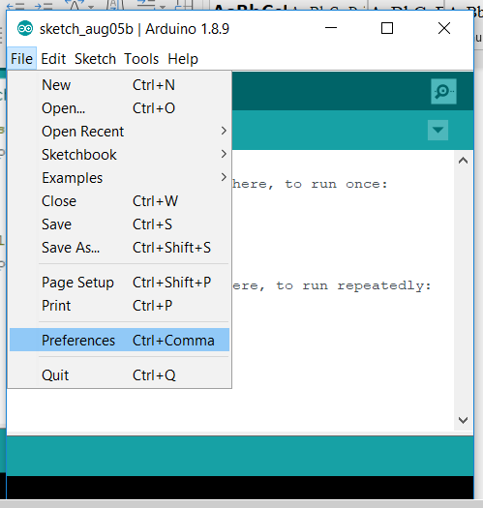
After installation is complete close the Boards Manager window.
“

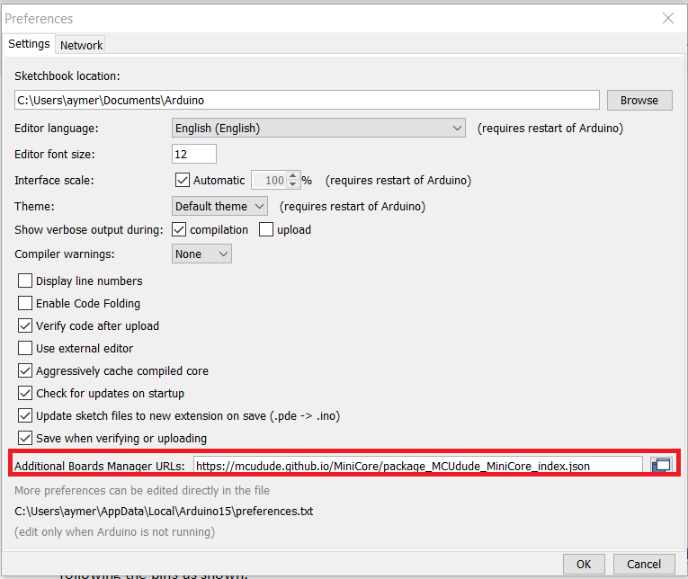
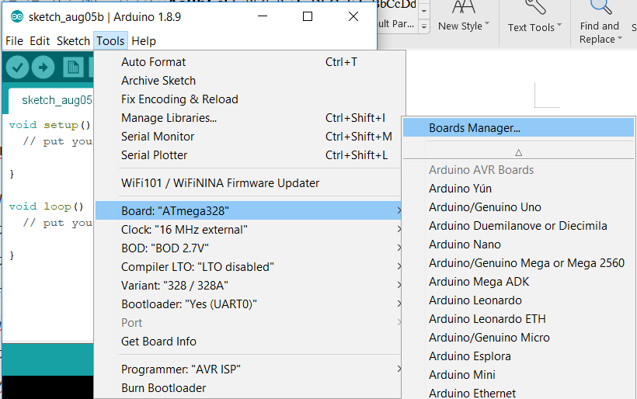
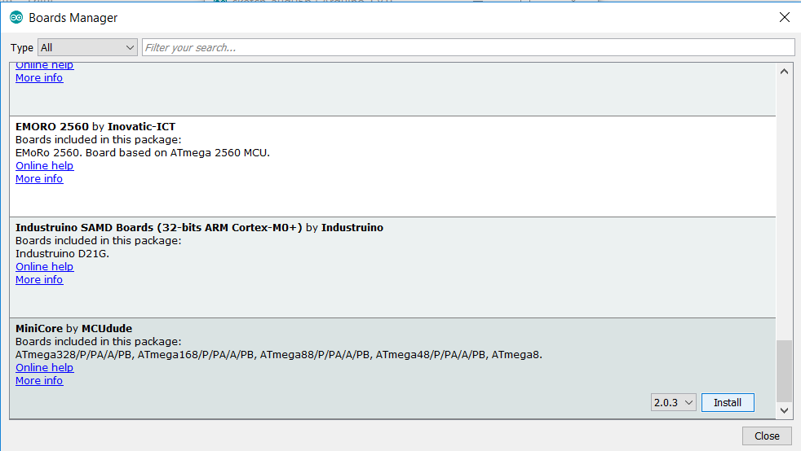
- Burning the bootloader onto the chip:
Plug the USBasp device into your computer.
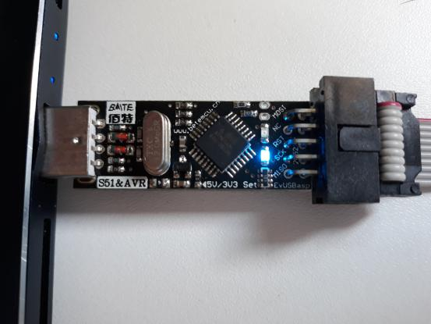
If you get an error stating the USBasp cannot be found:

Use Zadig to download the device driver:

Go to : https://zadig.akeo.ie and download the software. Once downloaded
Launch the spftware and go to Options>List all devices
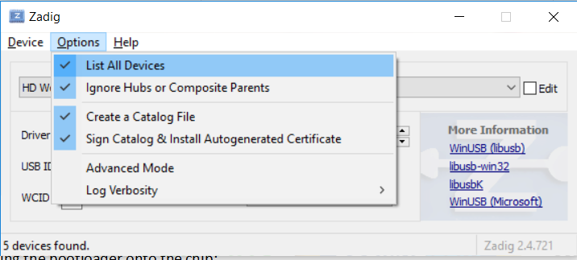

In the dropdown menu, select usbasp.
Then in the Driver selection click the small arrows until you find “libusbK (v3.0.7.0)”
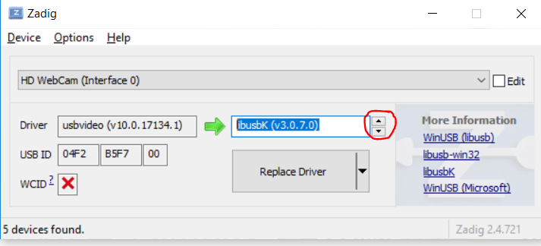
Then click “Replace Driver”

- - Inside of arduinoIDE go into tools>Programmer>USBasp;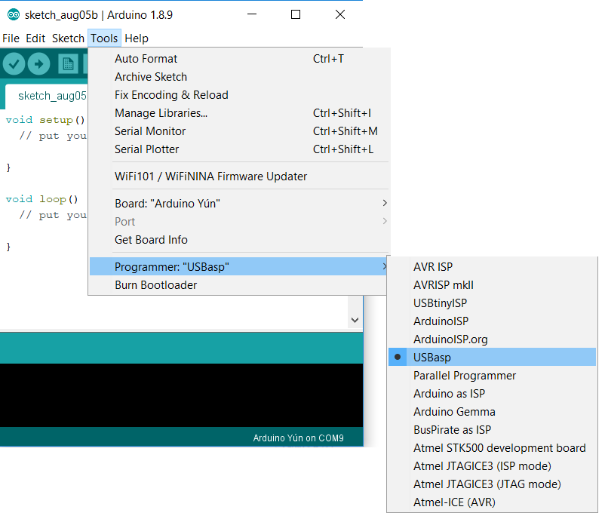

-Select the board ATmega328
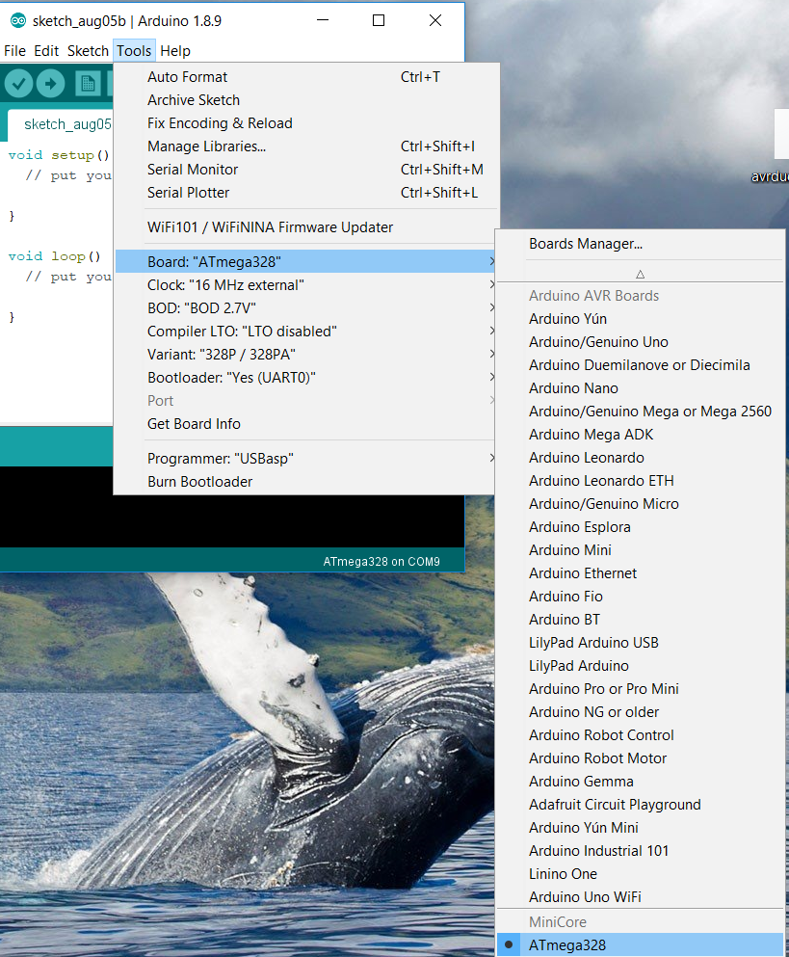
-and the variant 328/328A
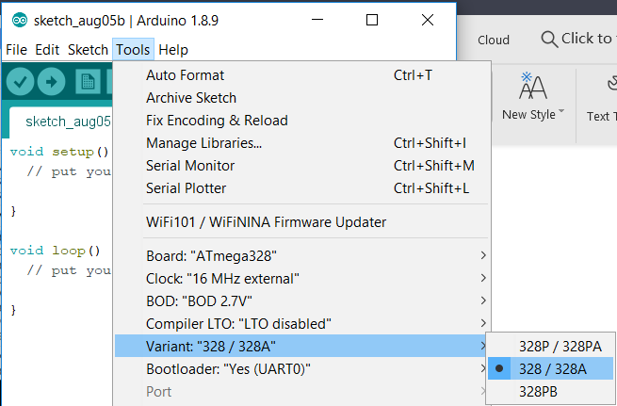
- Connect the USBasp as shown:
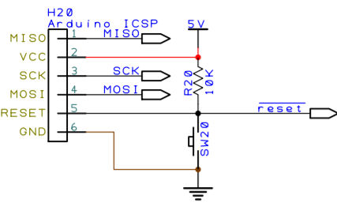
If unsure, the pinout is on the board or use the following schematic:
.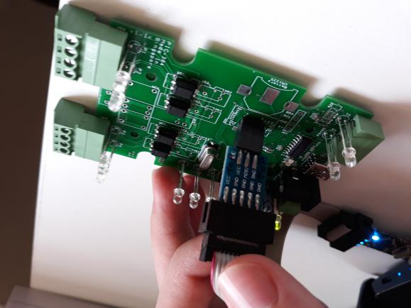

-go to tools>Burn Bootloader
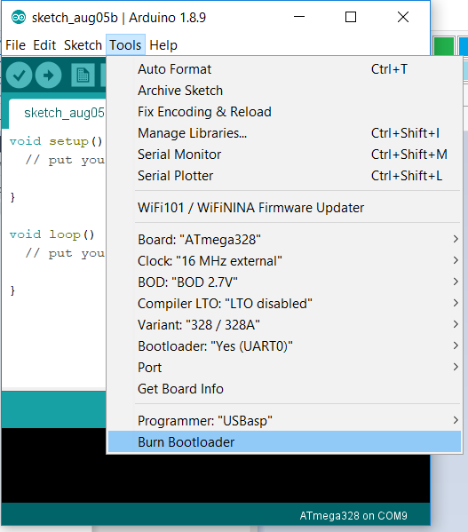

You should see this message in the console:
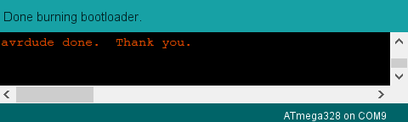

to check if the bootloader was carrectly burned, try using step 4. to load an empty Code.
If the loading fails, try changing th port in Tools>Port. If the loading still not works, try redoing steo 3. for the start.

- Programming the Board:

You can program the board using a USB B mini, just like you would a normal arduino Board.
For this you need to change the port if nescessary: Tools>Port

Use the Check button to compile ans the arrow to load the code onto the board.
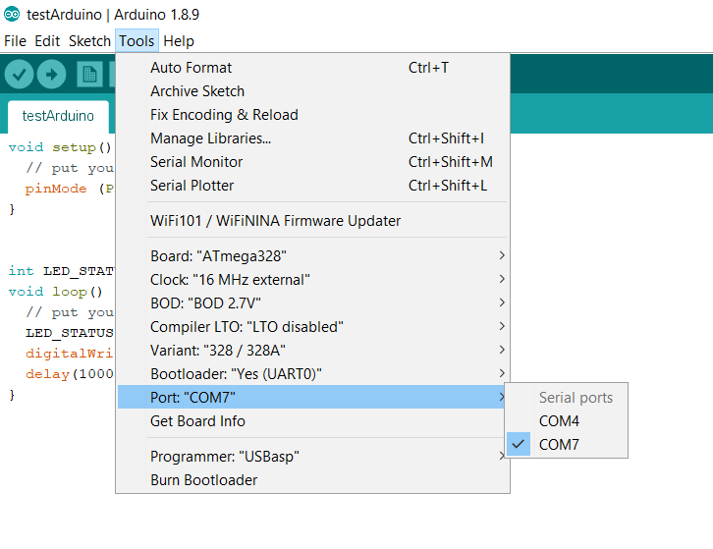

Set up:

The pins of the USBasp must be connected to the corresponding of the arduino ICSP connector.
